Polgar Superstar Chess (Starchess)
Website: http://polgarstarchess.com
Invented by László Polgár, father of the famous Polgár sisters, Starchess is played on a star-shaped board with rules which are very similar to those from classical chess.
Both white and black has a king, a queen, a bishop, a knight, a rook and 5 pawns. The game begins from the following position with pawns already placed on the board:
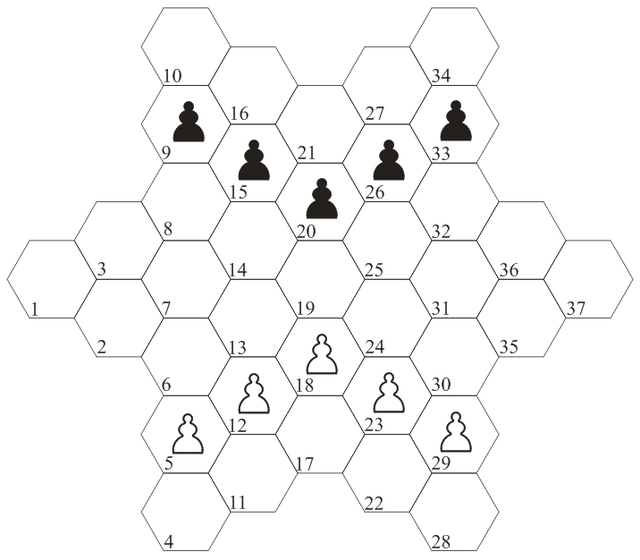
The first phase of the game is the setup: white and black places alternately their other men one-by-one on the back rank behind the pawns in no particular order. We could arrive for example to the following starting position (1 of 14400):
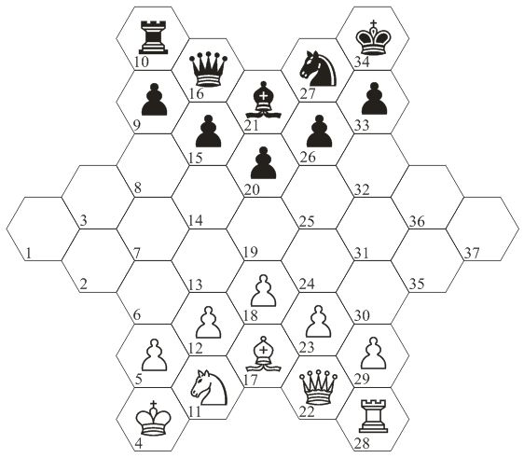
The movement of pieces:

The pawn moves forward and captures diagonally. Only the pawn's first move can be two cells forward:
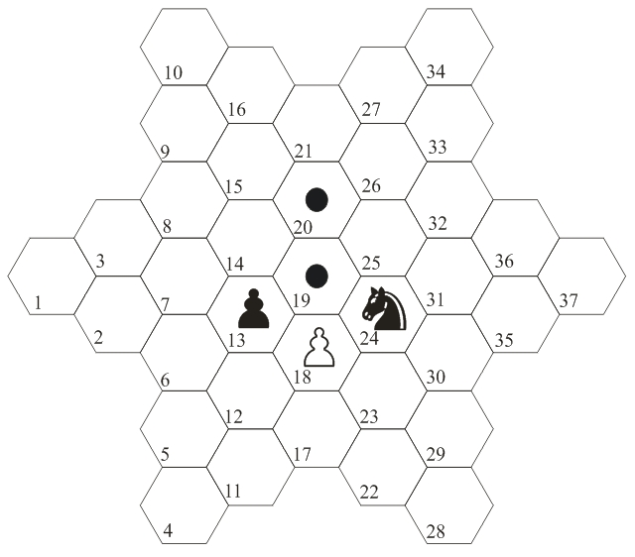
The king moves to a neibouring cell:
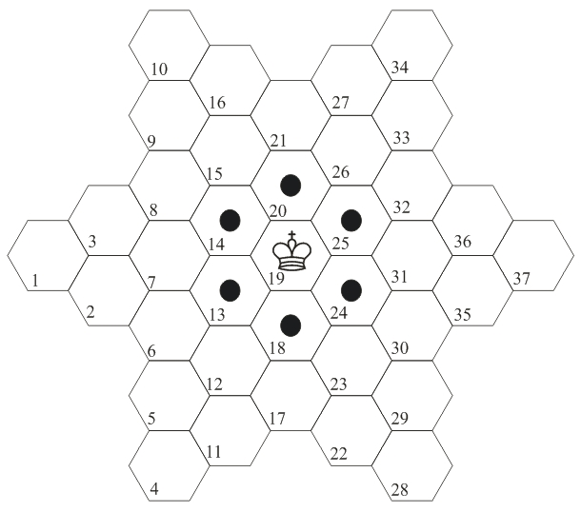
The rook moves only vertically:
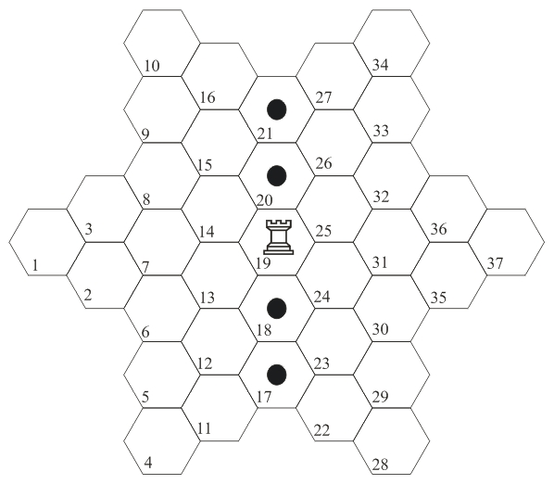
The bishop moves diagonally:
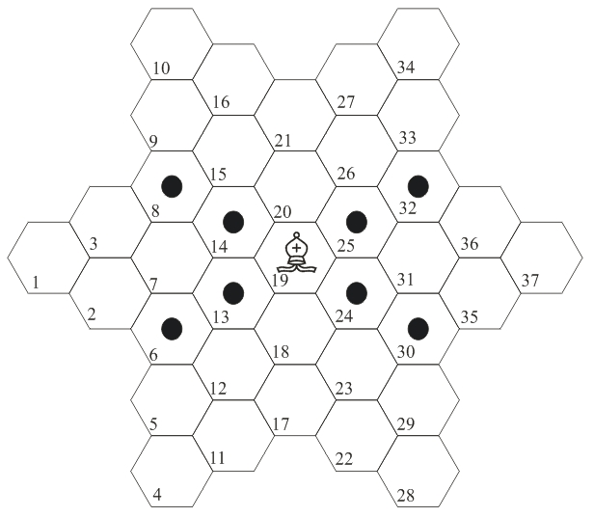
The queen moves in every direction one or more cells:
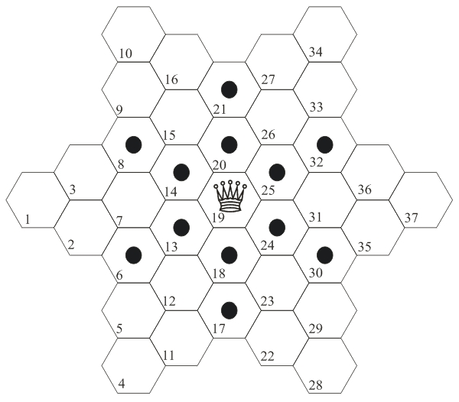
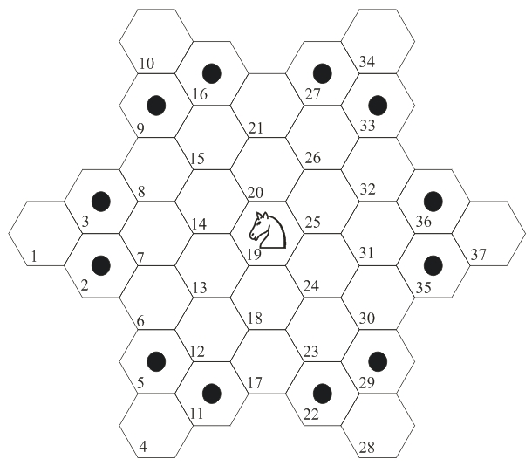
The knight jumps:
Promotion
When a pawn reaches the opposing side’s back rank, then it immediatelly has to promote to a queen, bishop, knight or rook of the same color.
Checkmate
The main objective of the game is to checkmate the opponent’s king. An example for a mate position is the following: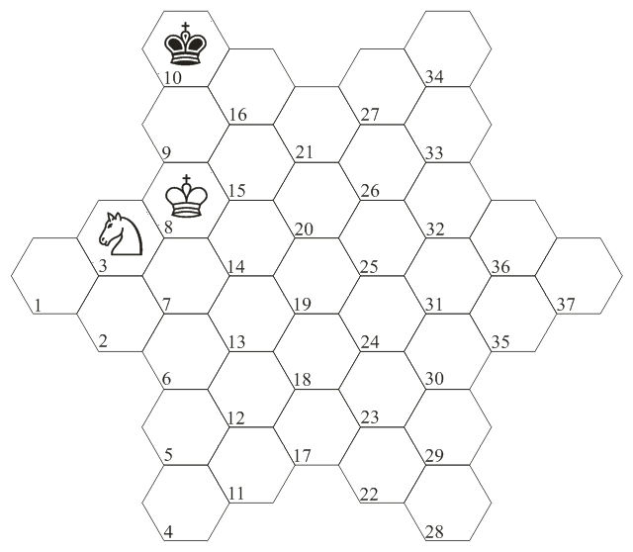
Stalemate
A stalemate is a position were the side which is on move doesn’t have any legal move and his king is not in check. An example:
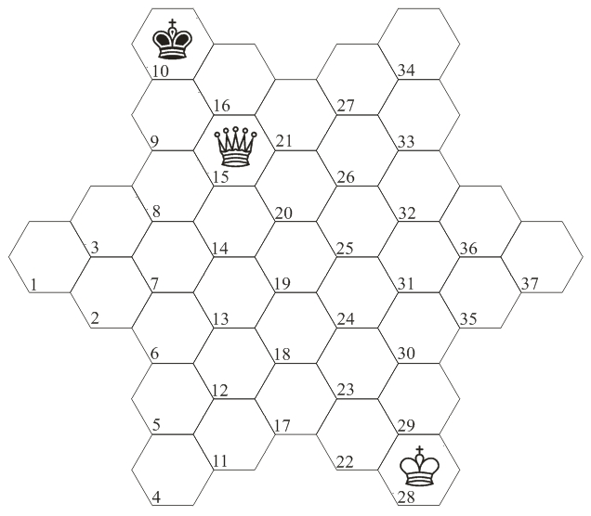
The end of the game
The possible result of a game is win for one side or a draw.
Win:
- one side checkmates the opponent’s king
- one side gives up the game
- one side oversteps the time limit
Draw:
- a stalemate position is reached
- there is insufficient material left to give checkmate
- by repetition of the same position on the board three times
- by 50 move rule - no captures and pawn moves over 50 moves. (Endgames proved by tablebases to requare more than 50 moves are exceptions from this rule!)
- a draw proposal during the game is accepted by the other side
En passant and castling moves
There are no such special moves in Starchess.
Vocabulary
limping pawn: a pawn which is on an initial cell and apparently can move two steps forward, but it has lost that possibility by already making a capture. (Remember, only a pawn’s first move can be two cells forward!)
dead pawn: a pawn which is on cell 2, 3, 35 or 36 (it has to capture once to have a chance to promote)
mummy: a pawn which is on cell 1 or 37 (very rare in practical games)
A game
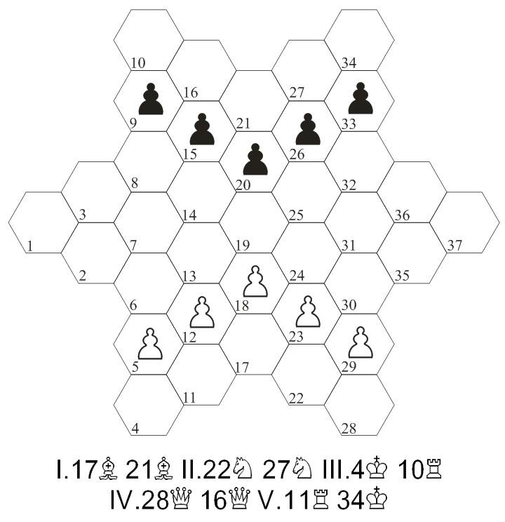
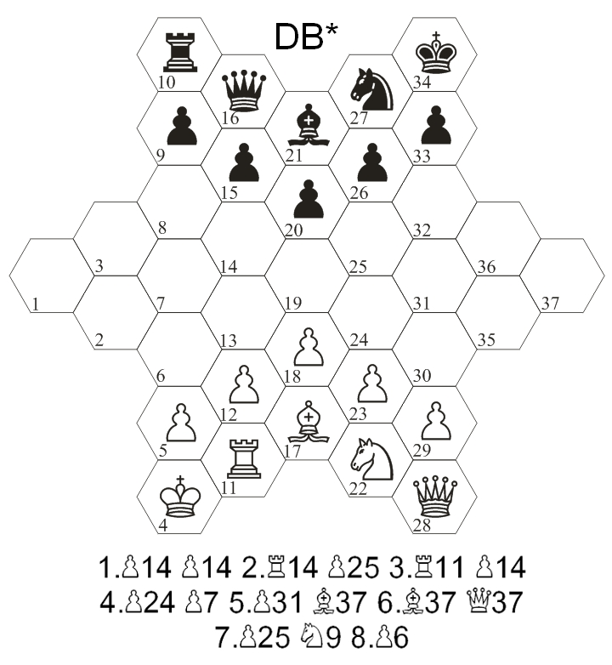
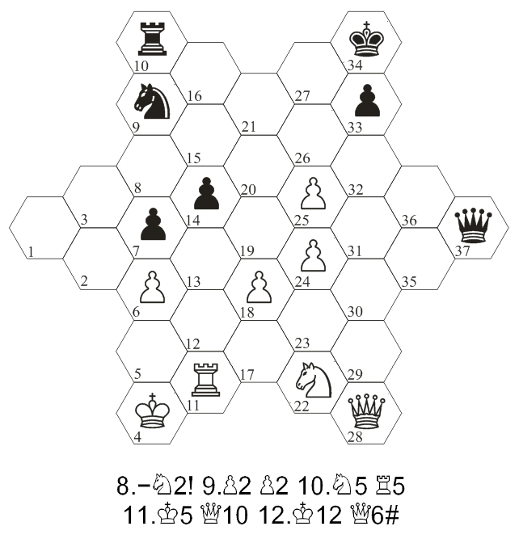
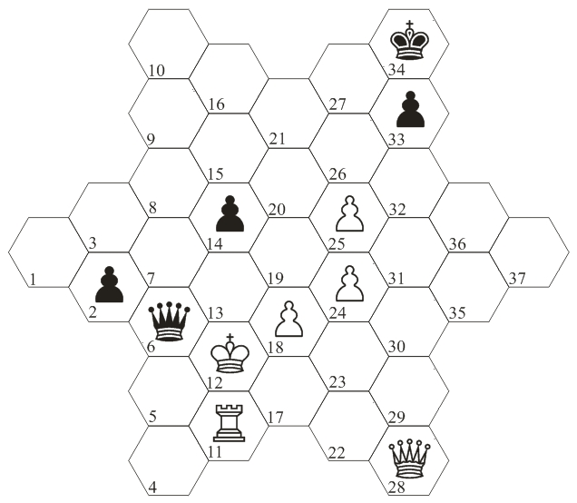
The white king is in checkmate. Black wins.

